**Methods and ways of calling a method**

1) Call-by-value

**package** Methods;

**public** **class** call_by_value {

**int** val=300;

**int** operation(**int** val) {

val =val*10/100;

**return**(val);

}

**public** **static** **void** main(String args[]) {

call_by_value d = **new** call_by_value();

System.***out***.println("Before operation value of data is "+d.val);

d.operation(100);

System.***out***.println("After operation value of data is "+d.val);

}

}

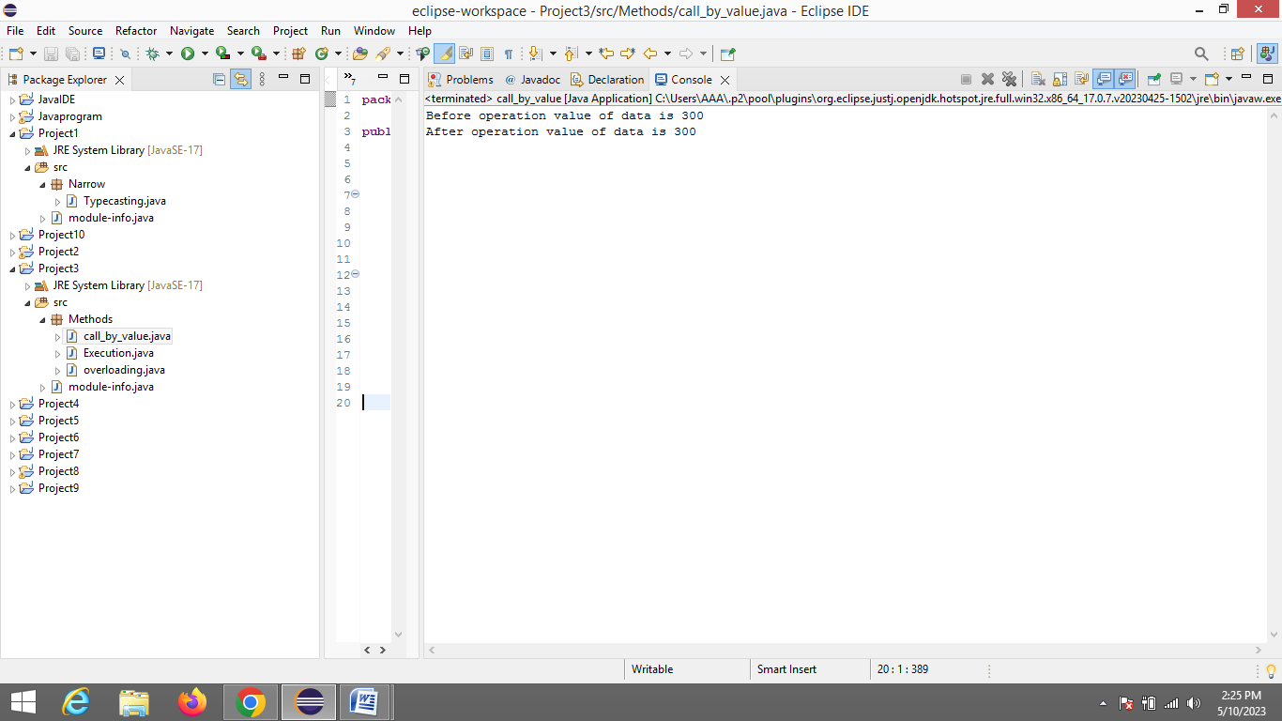

2) Execution

**package** Methods;

**public** **class** Execution {

**public** **int** multipynumbers(**int** x,**int** y) {

**int** z=x*y;

**return** z;

}

**public** **static** **void** main(String[] args) {

Execution b=**new** Execution();

**int** ans= b.multipynumbers(10,3);

System.***out***.println("Multipilcation is :"+ans);

}

}

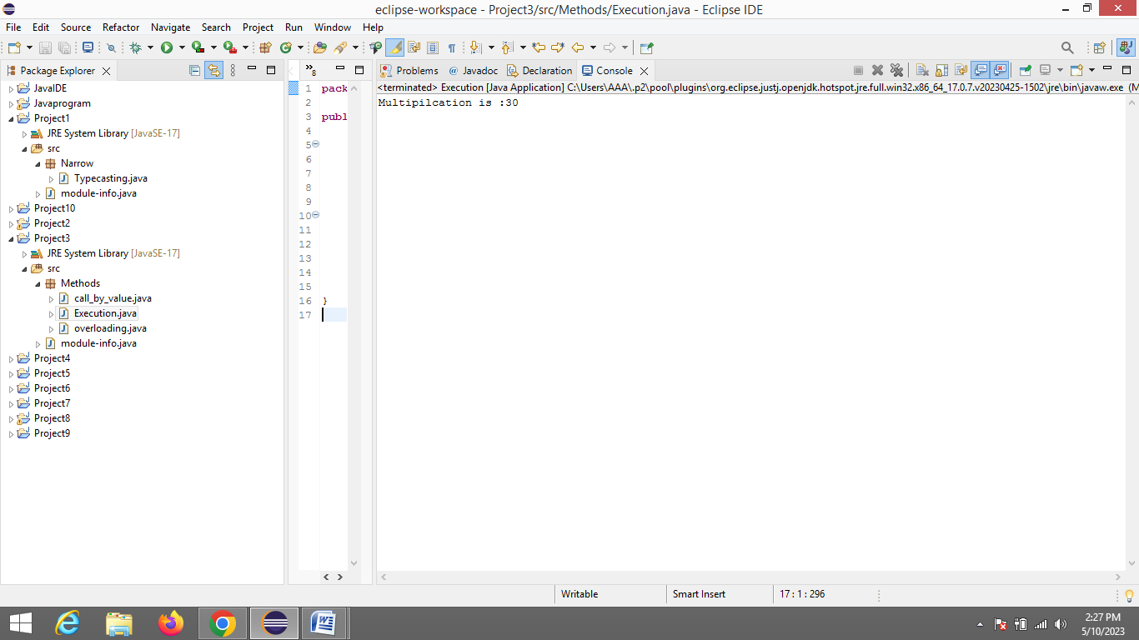

3) Over loading

**package** Methods;

**public** **class** overloading {

**public** **void** area(**int** b,**int** h)

{

System.***out***.println("Area of Triangle : "+(0.5*b*h));

}

**public** **void** area(**int** r)

{

System.***out***.println("Area of Circle : "+(3.14*r*r));

}

**public** **static** **void** main(String args[])

{

overloading obj =**new** overloading ();

obj.area(11,21);

obj .area(8);

}

}

